


FUNDAMENTAL SPREADSHEET APPLICATIONS
(230)

National 2020

Production Portion:

Job 1: Create Spreadsheet with Formulas (130 points)
Job 2: Format Spreadsheet (95 points)
Job 3: Create Clustered Column Chart (45 points)

TOTAL POINTS (270 points)

Failure to adhere to any of the following rules will result in disqualification:
- Contestant must hand in this test booklet and all printouts. Failure to do so will result in disqualification.
- No equipment, supplies, or materials other than those specified for this event are allowed in the testing area. No previous BPA tests and/or sample tests or facsimile (handwritten, photocopied, or keyed) are allowed in the testing area.
- Electronic devices will be monitored according to ACT standards.

No more than ten (10) minutes orientation
No more than ninety (90) minutes testing time
No more than ten (10) minutes wrap-up

Property of Business Professionals of America.
May be reproduced only for use in the Business Professionals of America
Workplace Skills Assessment Program competition.

GENERAL INSTRUCTIONS

- Make certain this test booklet contains Jobs 1-3.
- Key all jobs according to the instructions given.
- Correct any obvious keyboarding errors and incorporate any editing notations.
- Correct any errors in formatting. Use formatting shown in the Style & Reference Manual.
- For any problem where you would normally key your reference initials, key your contestant number. Your name or initials should not appear on any work you submit.
- Key your contestant number and job number as the footer in the lower left-hand corner of all work submitted unless otherwise specified.

Example:
99-9999-9999
Job 1

- If you finish before the end of the testing time, notify the proctor. Time may be a factor in determining a winner when there is a tie score.
- When turning in your materials, place your scoring sheet on top of your jobs. The jobs should be arranged in numerical order. Turn in all partial jobs completed
- Center all worksheets vertically and horizontally to print on one page.
- Print all worksheets in Landscape format.
- Print each chart on a separate sheet.

Scenario

Professional Business Association was hired by a local book store to create a spreadsheet for the last five years of book sales. Please use the data given to complete this spreadsheet.

GRADER: points are all or none unless otherwise noted!

Job 1 (Worksheet with formulas) | Points Possible | Points Earned
Contestant # and Job # in left section of footer | 5
11 pt. Times New Roman font used for data | 10
Input Data as shown in illustration | 10
Text file inserted into cell A7 | 10
A11 and G1 have Total Sales text entered | 5
A12 and H1 have Average Sales text entered | 5
Blank row entered above row 11 | 5
B12 function that calculates total sales for year 2014; function filled across to the other years | 10
B13 a formula that calculates the average sales for 2014. Fill formula across for all the years. | 10
G2 create a function that calculates the total sales for the genre. Fill the function down to the other genres. | 10
H2 create a formula that uses the Total_Sales named range that calculates the average sales for the genre. Fill the formula down for the other genres. (NO POINTS if AVG function used) | 10
G14 place the text Max Sales. | 5
H14 place a function to find the maximum average sales. | 5
Custom Sort the information based on genres in alphabetical order. | 10
Column widths adjusted to see information | 5
Center vertically and horizontally on one page | 5
Print out is in landscape view with the worksheet centered on the ONE page with gridlines and headings | 5
Print out of formulas in landscape view with the worksheet centered on ONE page with gridlines and headings and ALL formulas fully visible | 5
Subtotal | 130

Job 2 (Formatted worksheet) | Points Possible | Points Earned
Contestant # and Job # in left section of footer | 5
11 pt. Times New Roman font used for data | 10
Input Data as shown in illustration | 5
Text file inserted into cell A7 | 15
A11 and G1 have Total Sales text entered | 10
A12 and H1 have Average Sales text entered | 10
Blank row entered above row 11 | 5
B12 function that calculates total sales for year 2014; function filled across to the other years | 5
B13 a formula that calculates the average sales for 2014. Fill formula across for all the years. | 5
G2 create a function that calculates the total sales for the genre. Fill the function down to the other genres. | 5
H2 create a formula that uses the Total_Sales named range that calculates the average sales for the genre. Fill the formula down for the other genres. (NO POINTS if AVG function used) | 5
G14 place the text Max Sales. | 5
H14 place a function to find the maximum average sales. | 10
Subtotal | 95

Job 3 (Clustered Column Chart) | Points Possible | Points Earned
Job 3 (Stacked Bar Chart) | 5
Contestant # and Job # in left section of footer | 10
Stacked Bar Chart created on its own sheet named Book Sales Chart | 10
Printed on full sheet, landscape in Black & White | 5
Format chart to style 8 | 5
Correct title entered with 18 pt font | 5
Format the X Axis as Currency, no decimal places | 5
Subtotal | 45
TOTAL POINTS | 270

JOB 1: Create Spreadsheet with Formulas

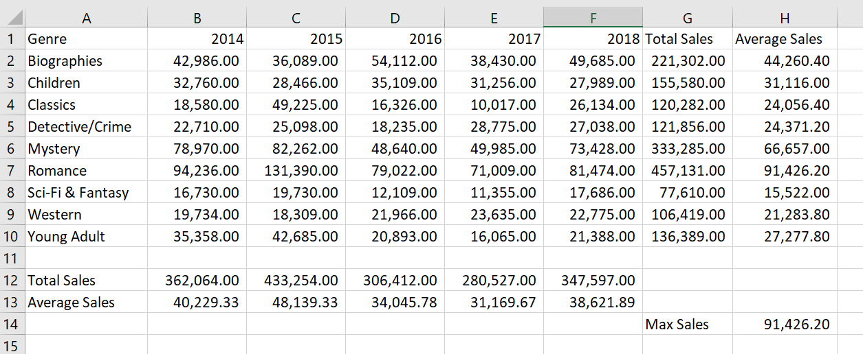

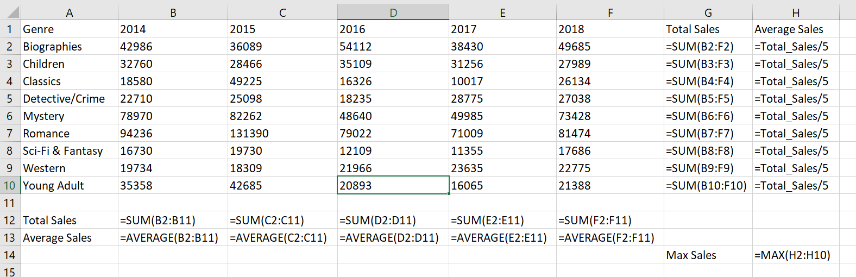

Grader Notes:
- Spreadsheet is printed vertically and horizontally centered
- Printed landscaped and fit to one page
- Contestant ID and Job # in the left footer
- Average Sales (H2:H10) formula can done in multiple ways
  - Check the number and that there is a formula in that location

JOB 2: Format the Spreadsheet you created in Job 1 using the following instructions:

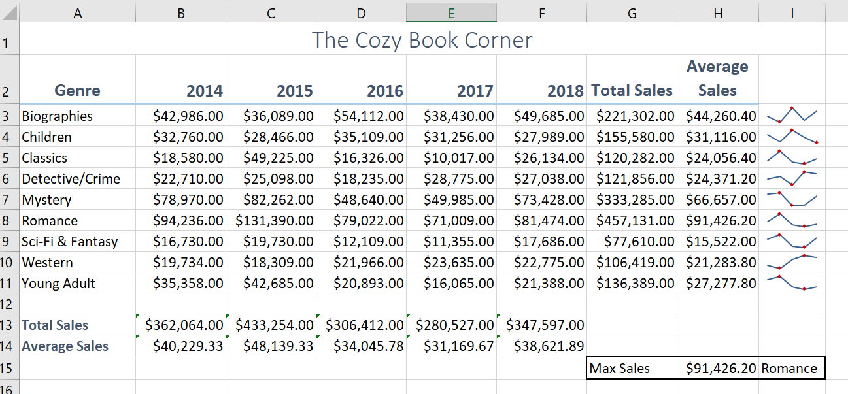

Grader Notes:
- Spreadsheet is printed vertically and horizontally centered
- Printed landscaped and fit to one page
- Contestant ID and Job # in the left footer

JOB 3: Create a Stacked Bar Chart.

